***PLASTIC PULLOUTCEAN FINAL REPORT***

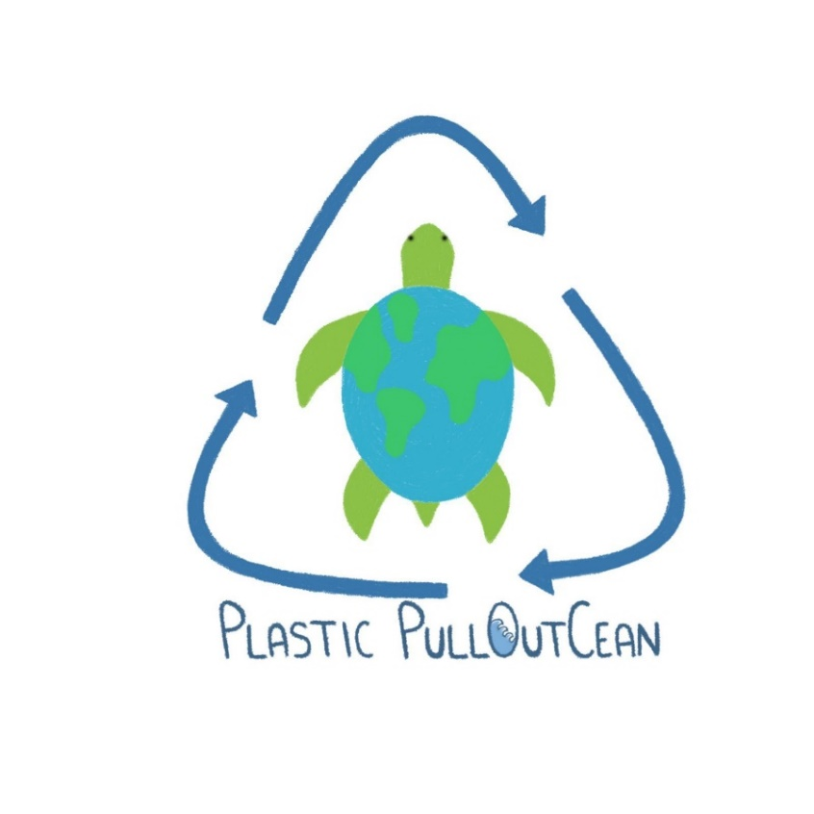

PlasticPullOutCean (crasis of “*Plastic Pull Out of Ocean*” mixed with the sound of “*Plastic Pollution*”) is an innovative project that interconnects an interactive exhibition and an app, to sensibilize and try to improve the problem of plastics in the oceans.

The idea is to change people’s minds, increasing the awareness around this problem, to push them to act before it is too late and plastics reach the ocean.

To achieve this goal, we created two different interfaces:

1. An emotional interface to perform a claustrophobic exhibition in a virtual ocean full of plastic
2. A social interface in an app to take part in 21 days challenge to collect plastic around the city

**PROBLEM STATEMENT**

Day by day, plastic is flowing into our natural environment in many different ways. Unfortunately, the endpoint of this trip is often the Ocean. The amount of plastic there increases by a quantity equivalent to 33800 plastic bottles every minute, nowadays it has reached like 3 times France’s surface dimension. This is a huge problem for the environment and especially for animals which populate our seas. Every year, ocean pollution kills 100000 animals surrounded by our plastic garbage. Even humans eat plastic without realizing it by micro and nano plastics, which can create hormonal dysfunctions and we still do not know the future consequences. We should act before plastics reach oceans, because, after that, collecting those items becomes more difficult. In fact, that plastic cannot be recycled without any chemical treatment because of microorganisms that populate the sea. Moreover, some of those plastic items are used by animals like houses or to protect themselves. For all those reasons we need to act fast and now. We must avoid that our Ocean becomes a Plastic Ocean!

Understood the problem, our question was: how we can convince people to act?

**RESEARCH**

To better understand what it has done until now in this field in order to sensibilize people, we studied other kinds of exhibitions. We searched using two methods:

1. Research-based on topic and scope
2. Research-based on kind of exhibition

The first one brought us to find some interesting artistic installations made of plastics, some online games for kids, some apps to help in recycling, awareness campaign spots, sculptures in recycled plastic. In particular, we found “Plastic Reflectic”, a plastic reflective-interactive installation by Thijs Biersteker, Plastic soup Foundation. That was an interesting discovery, but even if interactive, it was too far from our idea of interactivity.

.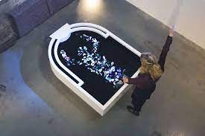

The second method brought us to two important studio labs: Studio Azzurro and Ars Electronica. They create great interactive installations using new media about many different topics but we did not find any project about plastic into oceans. Their innovative environments fully immersive and suggestive really inspired us. Their use of high resolutions projectors, lights and interaction with the users were important starting points for our exhibition.

Studying what we had found we understood that the natural market for our project was the same of these two studio labs, but with the heart of the first method’s results.

Our question at that moment was: how we can involve people, using an innovative interactive exhibition, until the point of taking action?

**WHAT IS THE BEST APPROACH TO INVOLVE PEOPLE?**

We tried to study some different approaches to create emotional engagement in our project. On one side, there were many studies about the importance of negative future realistic scenarios to interrupt a bad habit, for example this kind of attitude is used in against smoking campaign. On the other, there were some others that consider a positive one, highlighting the good part of giving up a bad habit, could be more successful. For this reason, we decided to have both approaches but in two different moments of our experience.

**Negative scenarios to increase awareness**

In the first part of our experience, we created an emotional interface that used the negative scenarios attitude. We projected a room, for a max.10 people, where people can feel how is to be surrounded by plastic in the ocean, starting from a situation without plastic and increasing that each time one person entered the room. Our idea was to create a claustrophobic experience in order to empathize with the sea animals around plastic islands. This is a very emotional part that points the finger to the users, presenting to them what humans are doing to oceans.

Was an interface like this one enough to push people to do everything useful to help and maintain this attitude?

We thought that was not a good way in the long period, so we decided to set up a challenge for 21 days to collect plastic around the city. But this was not just a boring duty.

Human is a social animal, as Aristotle said in the IV b.C., therefore we thought to exert leverage on this aspect. At the end of the exhibition, we invited our users to download our app to take part in the challenge. People who experienced the exhibition together became a team for the contest.

**Positive experiences and feedbacks to create a good behaviour**

We projected an app to take part in this challenge, that has just positive aspects, in particular the social effect, the possibility of bonding with other participants and enjoying the collection together. We based on the studies of Dr. Maxwell Maltz to choose the duration of the challenge, the doctor, in fact, discovered that 21 days are the minimum necessary to have a new habit. Actually, some other studies found out that they are not enough to maintain that in the long run, but it was a starting point, our hope was that people, after enjoying this kind of experience, could continue with the collection using our app for others challenges as an outsider. In this way, the gamification aspect of the app was another important pillar of our project.

Speaking about the positive feedback and the interconnection with the exhibition, at the end of the challenge, the user could relieve on the phone the visual part of the exhibition, but on reverse. In this way, based on how much plastic he/she had reached during the 21 days, he/she watched how much plastic disappeared from the virtual ocean.

**HOW TO CREATE A CONTEST TO COLLECT PLASTIC IN GROUP**

People that had the experience together became a team . Each of them competed with others in collecting plastic for 21 days. The app showed a general rank: this increased the cooperation inside a team and emphasized the gamification aspect. Each person could become the leader of his/her team, collecting more plastic than other members. He/she could score points by bringing plastics to a collecting point and framing with phone both each item and the bin. Using beacons and a machine learning algorithm to recognise objects, the app calculated a score for each kind of plastic item and showed some educational hints about it. At the end of the collecting day, the general and specific team ranks were updated: there was bonus and awards. When the contest ended the user could relive part of the experience re-watching the video of the exhibition on reverse, reaching a point with less plastic than the start, based on how much plastic had collected for 21 days.

**IDEATION OF PLASTIC PULLOUTCEAN**

We wanted to create two different interfaces, one emotional and the other one social with some aspects of gamification.

For each one we had to work on different levels, we started with a common one, the analysis of some aspects connected to the users.

**Methods of investigation: a questionnaire**

To better understand users’ needs, their knowledge of the topic and how much we could hold claustrophobia, we realized a form on google.

We reached 161 answers, thanks to them we oriented our user target. We decided to allow access to the exhibition to over 14 years old people, in order to not traumatize anyone.

Another important aspect revealed by the questionnaire was the importance to educate the average user about the problem, not so many people know in deep the problem of plastic in the ocean, we tried to deal with this side during the development of the app.

**The sketch and the storyboard of the room**

We sketched how we imagined our immersive 4D environment in the room and the instrumentation inside it. We chose to use air jets for the tactile and the smell part, speakers for the sonification aspect and 360° video-mapping for the visualization. We decided to have a collective experience in this way we used the emotional contagion technique

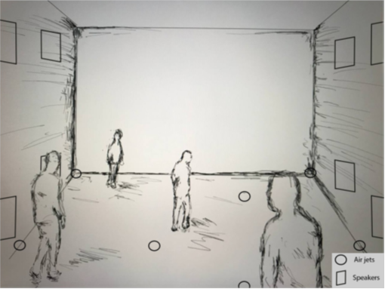

People could enter one each time, until they reached 10 people inside. We created a short video as storyboard to explain this initial interaction of the room. Here below we show some screenshots of it.

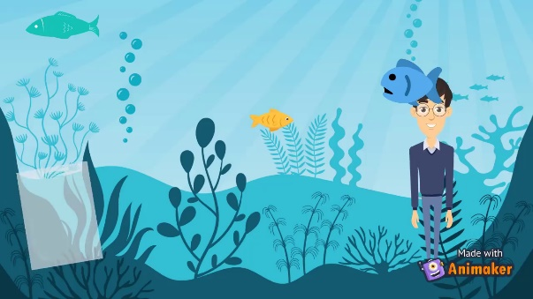 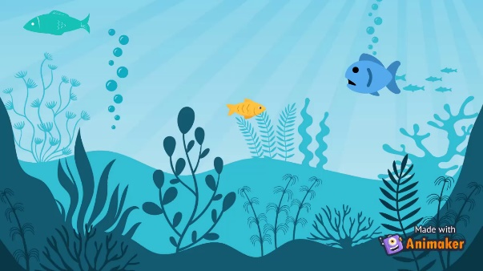 

**PROTOTYPES**

After that we moved on creating the prototypes of the two interfaces

**Exhibition’s prototype**

For the exhibition we created a demo, there, it was possible to appreciate the two most important aspects which we focused on: visualization and sonification.

Our exhibition had two different moments that were merged at some point:

1. Almost no plastic was projected all around, a turtle and a fish were swimming in peace. The users listen to relaxing music played in the room.

They could enjoy this experience and could be emotionally involved quickly by the two animals. At this point, we had the attention and the trust of the users

1. Broken of the relaxing phase, the users experienced an increasing anxiety thanks to the rise of the plastic all around and disturbing video of animals trapped into plastics. “The Mole” by Hans Zimmernwas played in the room, thanks to the “Shepard scale sound illusion effect” the feeling of claustrophobia was amplified

At the end of the exhibition, users were invited by a message to take action, downloading PlasticPullOutCean app to take part in the challenge: 21 days collecting plastic around the city.

**App’s prototype**

To achieve a prototype of the app we started from several wireframes of the principal screens. We wanted an app based on memorability, learnability and simplicity with some aspect of gamification, considering the contest proposed.

The app showed collecting points and other team members’ positions on a map, in order to meet each other during collection.

Here below we can see the general ranking, map and object detection’s wireframes.

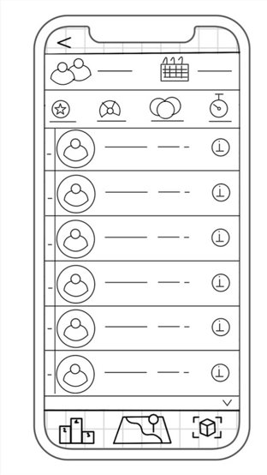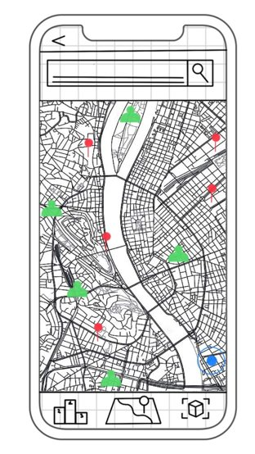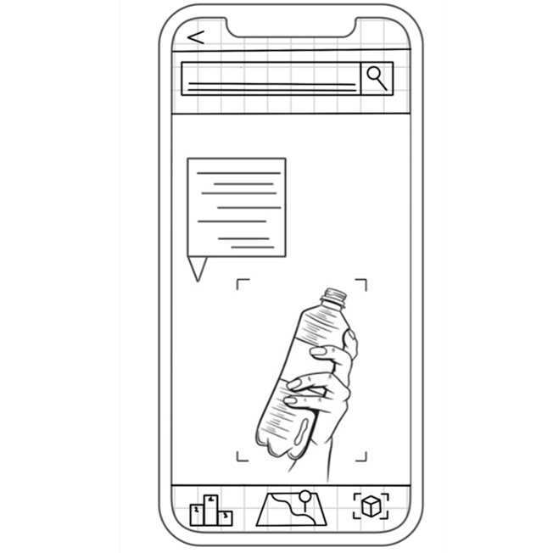

**High fidelity app’s prototype**

After creating the wireframes, we moved on implementing the high-fidelity prototypes based on the interface design rules. We chose to use the colours green and blue for the whole app, that recalled ocean and ecology.

After the logo screen, the first panel was the home, it was based on simplicity and contained just necessary information about the contest. On the lower part, we could see four different icons to reach all other screens with a tap: (from left to right): home, map (in augmented reality), ranking and detection of objects with camera. On the upper part we could see on the left settings and on the right the notifications icon, tapping it is possible to reach those two screens.

Here below we put just some screens of the prototype.

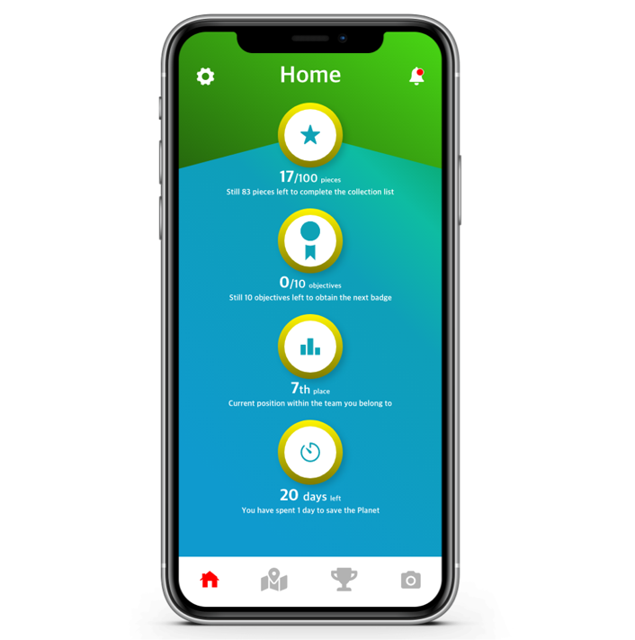

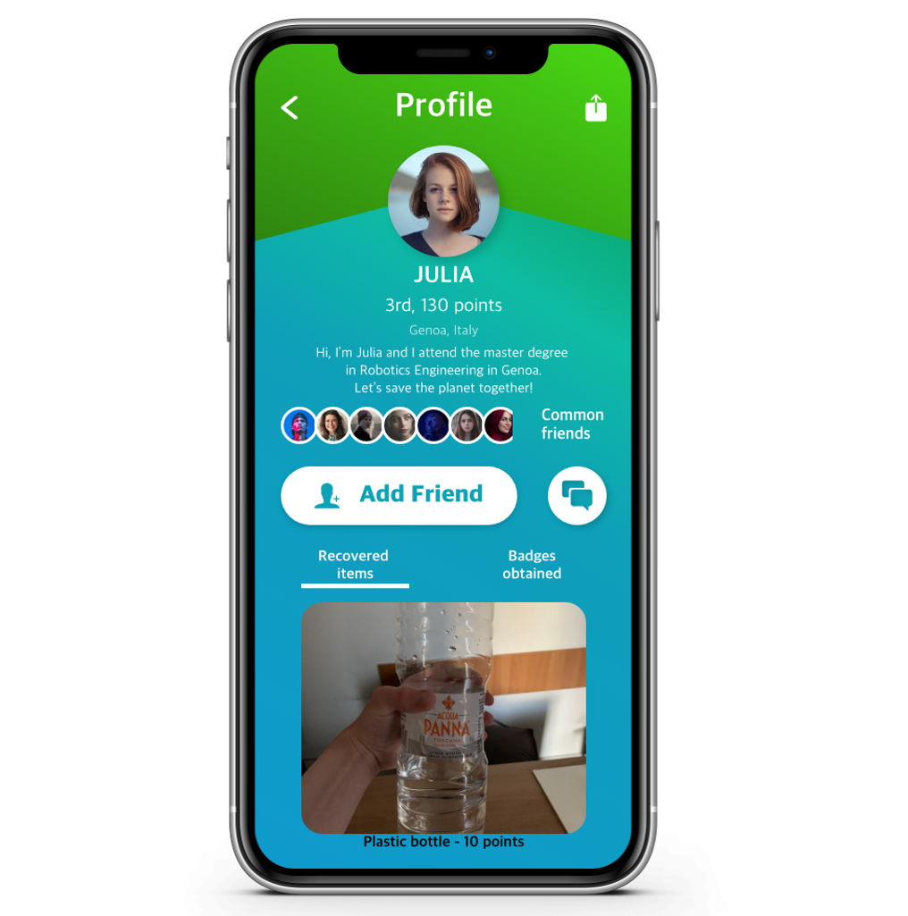

The leaderboard had an attached social part. The ranking was updated each time to take into account any change. Each participant's field led to their participant's profile page. The "community" icon redirected to the user’s friends list.

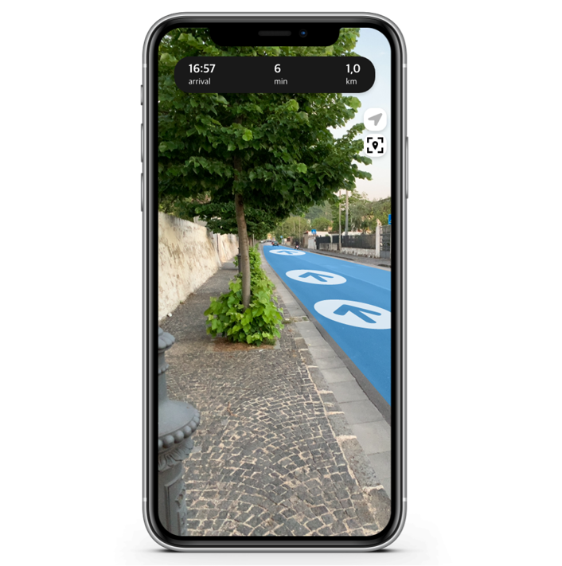

It was necessary to develop a map with adjoining navigation, in order to allow each user to reach a collection point. Once the navigation had started, the user could choose whether to use a standard or live mode, both supported by step-by-step directions.

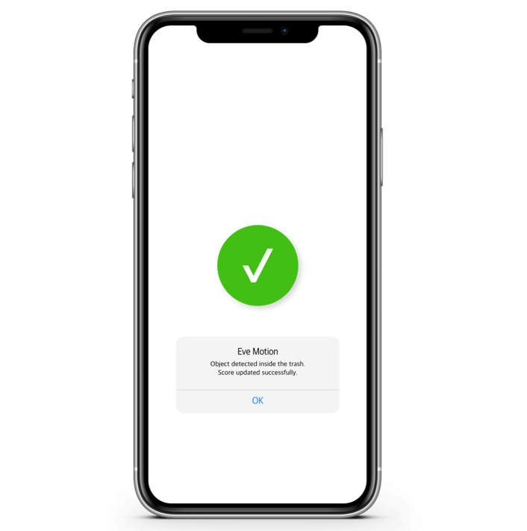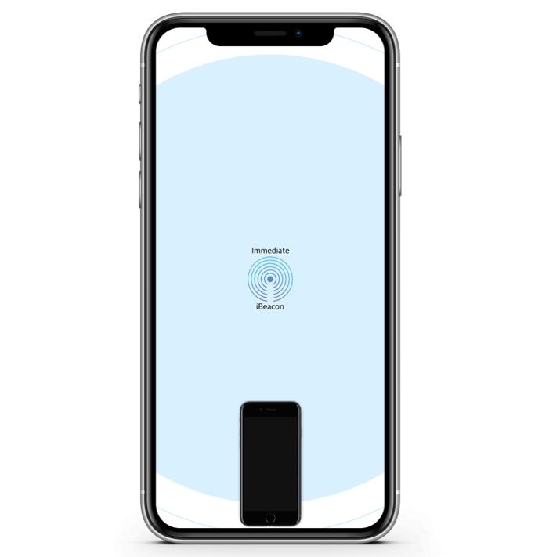

Using a specially developed recognition algorithm, it was possible to recognize a plastic object using the camera of its own device. According to the framed object, a score was assigned, and information was given regarding such material. Here we used the chucking and rehearsal technique in order to help the user to memorize this information. The assignment of points was subject to the immediate proximity of the user from the basket. This verification was facilitated using a beacon, positioned inside the basket itself. Once the refusal had been thrown into the trash, the user's score was updated. This verification was possible by a motion sensor, which was also positioned inside the basket.

The complete demo of the app is possible to find in the folder of our project.

**What about the future of PlasticPullOutCean project?**

We planned to improve and expand the interaction between the users and the exhibition. To achieve this goal, we would like to use some projectors on the ceiling that project pictures of plastic in correspondence of the passage of the first few users, like a corner of light, while they move inside the room. The idea is, using this metaphor, to explain how our single action impacts on the environment, even if we do not realize it at that moment. The user that follows that one who has left, while he/she was passing, the plastic behind should collect it. When the number of people inside the room is half of the maximum allowed, the plastic becomes too much to be collected.

What we want is that people understand that when the plastic reaches the ocean is too late, we should collect and recycle it before.

The hardest part of this improvement is to understand how to use in the most proper way the projectors to create a fluid and intuitive effect. We are pretty optimistic about the outcome!